**Understanding the role of global food trade on the transmission dynamics of antibiotic-resistant foodborne bacteria**

Alex L.K Morgan1, Mark E.J Woolhouse2, and Bram A.D van Bunnik2

1Centre for Immunity, Infection & Evolution and School of Biological Sciences, University of Edinburgh, Edinburgh, United Kingdom

2Usher Institute, University of Edinburgh, Edinburgh, United Kingdom

**ABSTRACT**

The role of livestock food products on the transmission dynamics of human AMR is a poorly quantified phenomenon. In particular, the influence of non-domestic food product import on disrupting local AMR dynamics has not been explored in literature. The relevance of importation on the transmission dynamics of AMR is likely to increase in importance in future years, with an increasing global reliance on imported livestock food products and an increase in demand for food product diversity. We use mathematical models to describe the transmission of AMR/foodborne disease from livestock to humans and explore the role of food product importation on the efficacy of local livestock antibiotic curtailment strategies, specifically in the context of reducing AMR in human populations.

Model parameters relating to food product importation, such as the prevalence of *Salmonella* spp. contamination on imports and the proportion of domestic food usage from imported sources, had a significant effect on disrupting the efficacy of livestock antibiotic curtailment. This can be attributed to an increase in foodborne disease attributable to non-domestic sources, which is subsequently unalterable through local interventions. Under a UK-specific case study, increasing the proportion of domestic food usage from imported sources resulted in sharp decreases in the efficacy of local livestock antibiotic curtailment. These decreases were exacerbated if the average overall/resistant level of *Salmonella* spp. contamination of imports was high. Increasing heterogeneity in the trading partners also had the effect of increasing uncertainty in the effects of import on the efficacy of curtailment. The importance of food importation on AMR dynamics suggests that alterations to trade policy must also consider the potential for negative consequences to the viability of “one-health” strategies aiming to tackle the ongoing AMR crisis.

**INTRODUCTION**

A “one-health” approach has been suggested as an effective strategy to tackle the ongoing antimicrobial resistance (AMR) threat (1). This integrated approach works on the principle that human, agricultural and environmental health are connected, and therefore an integrated approach across all three settings is required to tackle AMR. This has led to a focus on livestock as a potential driver of AMR in human populations, with transmission of AMR determinants/bacteria occurring through direct contact, foodborne transmission or indirectly through environmental contamination (2).

An association between livestock and human AMR has been demonstrated in literature. Examples include an identification of similar extended-spectrum beta lactamase (ESBL) genes/plasmids in clonally related *E.coli* present in both livestock/human hosts, a 24% reduction in the pooled prevalence of antibiotic-resistant bacteria in humans when antibiotic usage in animals was reduced and historical human outbreaks of multidrug resistant (MDR) *Salmonella enterica* linked to the consumption of raw milk (3-7). However, there is also an emerging body of literature identifying the contrary. This includes the use of whole genome sequencing (WGS) to identify a lack of association between livestock-associated and human blood-stream isolates of drug-resistant *E.coli* and identification of distinct lineages of drug-resistant *E.faecium* when sampling from retail meats, livestock and human populations (8, 9).

It is important to contextualise the lack of evidence for the cross-species transmission of AMR with the often-limited scope of sampling frameworks and the dearth of high-resolution epidemiological metadata to integrate with genomic analysis in order to identify transmission events (10). However, this uncertainty in the extent of AMR transmission between livestock and humans suggests that more research is required to better understand the transmission dynamics of AMR and how different transmission pathways may contribute to the dissemination of AMR across the livestock/human interface (11).

Foodborne pathogens (*Salmonella* spp. and *Campylobacter* spp.) represent an interesting case study to explore the potential spread of AMR from livestock to human populations, with host-restricted serovars such as *Salmonella* *enterica* serovar Typhimurium having a defined livestock reservoirs and being pathogenic upon colonisation in human populations (12). Unequivocal evidence also exists regarding the propagation of these foodborne pathogens through the farm-to-fork pathway, and with the identification of drug-resistant foodborne pathogens/genes found in all stages of food processing (13, 14). It is important to note that there is great heterogeneity in the livestock sources of these foodborne pathogens, with both domestic and imported food products playing a role in foodborne transmission and consequently AMR transmission (15-18). This is acknowledged in source attribution studies, using metagenomics approaches and epidemiological analysis to attribute AMR and foodborne disease to domestic/imported sources (19, 20). However, few studies have attempted to quantify the impact of imported food products on AMR transmission dynamics (18).

Heterogeneity in transmission pressure from spatially distinct subpopulations has long been identified as an important driver in pathogen disease dynamics (21). This has also been recognised in AMR literature with interaction between sub-populations and spill over of AMR drastically reducing the efficacy of local curtailment interventions, and with meta-population models predicting strain coexistence due to sub-population interaction and the maintenance of AMR (22-24). This provides an interesting avenue of research to explore heterogeneity in AMR transmission in the context of food product importation.

The need to explore the effect of food import on AMR transmission dynamics is also likely to increase in the future, with an increasing worldwide reliance on the imported food products to meet global demand for food and increasing demand for diversification of food products (25-28). Renegotiation of current trade agreements may also lead to a change in importation, with the UK experiencing an increase in non-EU imports in 2021, attributable to a trade-hub type effect, with a greater level of non-EU food products passing directly to the UK rather than being previously cleared in EU nations (29). Changes to trade policy may have significant implication on the transmission dynamics of AMR and the risk to human health, especially if there is an asymmetry in domestic/import policies regarding the implementation of “one health” to control AMR in food products (15, 30). However, there is a lack of studies that explore the potential effects of asymmetries in AMR/contamination in domestic/imported food products on overall human AMR transmission dynamics (16, 18).

In this study, we aim to address literature gaps in literature by exploring the impact of livestock food product import on AMR transmission dynamics within a UK-specific case study. We explore the potential impact of livestock food product importation on disrupting the efficacy of local livestock antibiotic stewardship, with a particular focus on livestock antibiotic curtailment and the subsequent effects on human AMR. Additionally, we explore the impact of alterations in importation parameters that reflect alterations to food trade policy, such as increasing heterogeneity in sources of importation and alterations to the reliance of the domestic country on imported food sources.

**METHODS**

**Homogenous Import Model**

A compartmental model was developed to describe the transmission of antibiotic-resistant and antibiotic-sensitive *Salmonella* spp. from domestic and imported livestock food products to humans (**Figure 1**). *Salmonella* spp. transmission dynamics were modelled explicitly for domestic livestock and human populations, with each modelled population stratified based on their infection status: susceptible humans (SH), humans infected with antibiotic-sensitive bacteria (ISH), humans infected with antibiotic-resistant bacteria (IRH), susceptible livestock food-animals (SA), livestock food-animals infected with antibiotic-sensitive bacteria (ISA) and livestock food-animals infected with antibiotic-resistant bacteria (IRA).

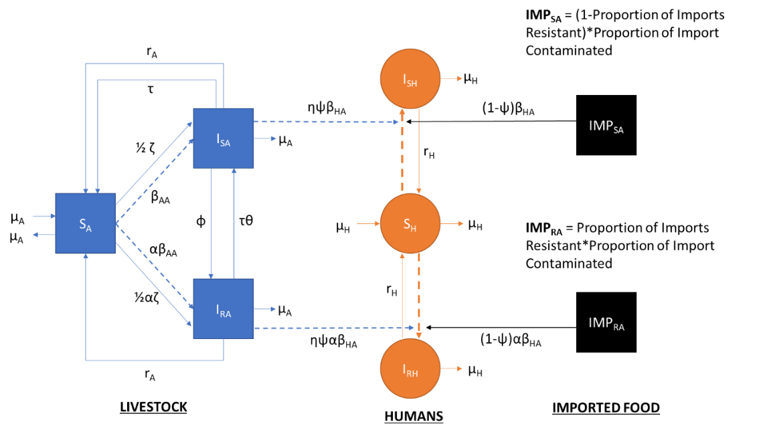

**Figure 1. Model structure describing the transmission of foodborne pathogens between/within livestock and human populations.** Model equations and parameters can be found described in the supplementary material (**SUPPLEMENTARY**).

The influence of imported food products was modelled as a constant transmission pressure to human populations. The proportion of imported food products contaminated with either antibiotic-sensitive/resistant *Salmonella* spp. was modelled as a function of the proportion of contaminated food products that are antibiotic-resistant (PropResImp) and the proportion of contaminated food imports with *Salmonella* spp. (FracImp). The proportion of food imports contaminated with antibiotic-sensitive bacteria follows the same calculation, is defined as the complement of the former parameter (1-PropResImp). We term this model, the “homogenous” import model.

Two transmission routes of antibiotic-sensitive/resistant *Salmonella* spp. were modelled. Domestic animal-to-animal transmission (βAA) and transmission from contaminated domestic/imported livestock animal carcasses/food products to humans (βHA). This βHA parameter represents either direct transmission from the carcasses or through food-borne transmission following further processing in the farm-to-fork pathway. Human-to-human and human-to-animal transmission routes were not modelled due to the focus of the study on the transmission dynamics of foodborne transmission of *Salmonella* spp. and the negligible role of both pathways on the foodborne transmission ([Infection with Salmonella (cdc.gov)](https://www.cdc.gov/training/SIC_CaseStudy/Infection_Salmonella_ptversion.pdf)). A relative scaling parameter was also used to model the relative reduction in *Salmonella* spp. prevalence from domestic livestock carriage to contamination on domestic livestock carcasses (η). This assumption was made due to the influence of caecum carriage on carcass contamination following accidental perforation during slaughter (31, 32).

A background rate of transmission in the livestock population was also modelled to represent infection of livestock hosts from non-livestock sources (ζ). This transmission rate was scaled by a factor of 0.5 to ensure an equal influence of ζ on both antibiotic-sensitive and resistant transmission routes. Natural recovery from antibiotic-sensitive/resistant infection occurs in both human/livestock populations at rate rH and rArespectively. Per capita birth/death rates are represented by µA in livestock and µH in human populations.

A parameter (τ) was used to describe the selective pressure and therapeutic effect of antibiotic usage in domestic livestock. The selective pressure of livestock antibiotics was modelled as a single transition rate, encompassing a range of evolutionary and biological phenomena that convert livestock between antibiotic-sensitive to resistant states. Similarly, a single reversion parameter (φ) was used to encompass a range of different biologically plausible phenomena that may cause reversion of antibiotic-resistant (IRA) to sensitive strains (ISA). **A description of these biologically plausible phenomena can be found in the methodology for Chapter 2.**

The relative influence of domestic food consumption from domestic livestock sources was modelled as a proportion (ψ), with 1-ψ representing the extent of human food products sources from imported sources. Future references to “increases in importation” (ψ → 0) or “decreases in importation” (ψ → 1) refer to alterations to this parameter.

**Heterogenous Import Model**

To explore the effects of import heterogeneity on antibiotic-sensitive/resistant *Salmonella* spp. transmission dynamics, the import pressure (FracImp, PropResImp) was stratified into multiple parameters. This represents the different countries that would constitute the food trade network for the domestic country (**Figure 2**), with each importing countries requiring individual parameterisation regarding the proportion of contaminated food imports with *Salmonella* spp and the proportion of contaminated food products that are antibiotic-resistant. As an example, with n = 10 importing countries, FracImp and PropResImp can be defined as: FracImp = [FracImp1, …, FracImp10] and PropResImp = [PropResImp1, …, PropResImp10].



Figure 2. **Model structure describing the transmission of foodborne pathogens between/within livestock and human populations in the model with increased import heterogeneity.** Model equations and parameters can be found described in the supplementary material (**SUPPLEMENTARY**).

The increased heterogeneity in import also requires the addition of another set of parameters describing the relative share that each importing country contributes to the overall importation in the domestic country of interest, Share = [Share1, …, Sharen]. Note that , due to the role of the parameter as a scaling factor.

**Model Case Study**

The United Kingdom was chosen as the “domestic” country of interest for the model. Therefore, the compartmental model, including dynamic livestock and human populations was parameterised with regard to UK livestock/human outcome measures.

The bug/drug/livestock population of interest was modelled as ampicillin usage/resistance in fattening pigs for *Salmonella* spp.. This case study was chosen due to the high level of usage (both historical and current) of ampicillin in fattening pigs, and the availability of resistance data for this livestock species. We note that the model was not meant to imply that fattening pigs are the sole source of ampicillin-resistant *Salmonella* spp. to humans. Rather it was intended to act as a case study to parameterise the data due to the difficulty in choosing a representative population to represent all possible drug/livestock combinations.

**Efficacy of Curtailment Outcome measure**

The primary outcome of interest for this study was the relative change in the proportion of ampicillin-human salmonellosis that are ampicillin-resistant upon domestic livestock antibiotic curtailment (τ = 0.0009 g/PCU → 0 g/pCU). We term this relative reduction as the “efficacy of curtailment” (EoC) (eqn 1.1).

Eqn 1.1

This outcome measure is calculated at the long-term model non-zero steady state. Studying the system at an equilibrium state is a useful indication of the long-term dynamics of antibiotic-resistant salmonella infection and the long-term trajectory of the system. However, we recognise that the “real-world” dynamics of AMR are not temporally stable and in flux.

**Data Sources and Model Fitting**

An approximate Bayesian computation sequential Monte Carlo (ABC-SMC) approach was used to fit the model to the ampicillin usage/resistance in fattening pigs case study, using the United Kingdom as the domestic country of interest. This required the curation of three different datasets.

The first dataset was a usage/resistance dataset to parameterise the relationship between domestic livestock ampicillin usage and the proportion of contaminated food products that are antibiotic-resistant (**SUPPLEMENTARY**). This was required to ensure that reductions in domestic livestock antibiotic usage result in reductions in livestock AMR have dynamics grounded in reality. The proportion of ampicillin-resistant isolates from fattening pig carcasses was extracted from the respective European Food Safety Authority (EFSA) summary reports (33-36). Ampicillin sales data was obtained from European surveillance of veterinary consumption (ESVAC) reports (37-40). A scaling calculation was required to convert the generic ampicillin sales for livestock to a value specific to fattening pigs with sales described as grams per population correction unit (g/PCU). **Details of this scaling calculation and proof of the temporal stability of the data can be found in the supplementary information for chapter 2**. Note that due to a lack of accurate country-level antibiotic usage data, sales were assumed to be a proxy for usage.

The second dataset was curated to parameterise import-relevant PropResImp, FracImp and Share parameters. Data from the UK Department for Environment & Rural Affairs (DEFRA) was used to identify the UKs major livestock food product trade partners (41). The EU was stratified into nine distinct import sources/countries: Netherlands, Irish Republic, Germany, France, Spain, Italy, Belgium, Poland, Denmark, and a single non-EU import source. Scaling calculations were required to determine the relative contribution of these ten contributors to the UKs food supply for general livestock food products (ψ = 0.656) and swine-specific food products (ψ = 0.4455). **Details of these scaling calculations can be found in the supplementary material** (**SUPPLEMENTARY**). Note that data on the contribution of domestic, EU and nEU countries/regions for general livestock food products (ψ = 0.656) was used for baseline model parameterisation. Data on the proportion of *Salmonella* spp. contaminated food imports (FracImp) was obtained from ECDC surveillance reports, with contamination data obtained from 400cm2 swabs and competent authority (CA) surveillance prioritised (42-45). Data on the proportion of isolates obtained from contaminated swine carcasses that are antibiotic-resistant was obtained from EFSA surveillance reports. This was used as a proxy for the proportion of contaminated food products that are antibiotic-resistant (PropResImp).

The third dataset focused on data regarding UK-specific livestock/human outcome measures to act as targets for model fitting. Baseline UK ampicillin usage/sales for the ampicillin-resistance in fattening pigs case study was considered the unweighted average ampicillin usage observed across 2015-2018 for the UK (τ = 0.0009 g/PCU). The observed ECDC daily EU incidence of human salmonellosis was used as a proxy for the baseline incidence of UK salmonellosis (0.593 per 100,000). This proxy was chosen due to the lack of multiplication factors available to scale UK-specific reported incidence of salmonellosis to community levels (46). The proportion of ampicillin-resistant UK human salmonellosis was obtained from 2015-2018 ECDC AMR summary reports (0.207). The proportion of ampicillin-resistant UK livestock Salmonella spp. carriage was parameterised from 2015-2018 EFSA surveillance reports (0.417). The proportion of contamination in UK swine carcasses was calculated from 2015-2018 ECDC one health surveillance reports (0.0628). **Details of the calculations to determine these UK-specific outcome measures can be found in the supplementary material** (**SUPPLEMENTARY**)**.**

The η parameter was also parameterised using UK specific data, with a caecum carriage of *Salmonella* spp. in UK fattening pigs identified at 32.2% (31). This information was combined with data on the extent of UK *Salmonella* spp. contamination on fattening pig carcasses (2.87%), to parameterise an 88.98% reduction from carriage to contamination in UK livestock (η = 0.1102).

**ABC-SMC Model Fitting**

A simulated dataset for the ampicillin-resistance in fattening pigs case study was generated by modelling the proportion of ampicillin-resistant livestock carriage for each country/year observation, for each of the observed levels of antibiotic sales included in the dataset. A sum of squared errors distance function was then used to calculate the distance between the simulated and observed fraction of antibiotic-resistant livestock infection for each country/year data point. In accordance with the EFSA methodology, countries with <10 isolates in the respective EFSA dataset for a particular year were omitted from the dataset

Four additional summary statistics were used in the fitting approach: 1) minimise the difference between the modelled daily EU incidence of human salmonellosis at baseline antibiotic usage and the observed ECDC daily EU incidence of human salmonellosis currently observed (0.593 per 100,000), 2) minimise the difference between the model estimated proportion of ampicillin-resistant human salmonellosis at baseline antibiotic usage and the UK-specific proportion of resistant human salmonellosis (0.207), 3) minimise the difference between the model estimated prevalence of *Salmonella* spp. contamination on swine carcasses and the value observed for surveillance data (0.0628) and 4) minimise the difference between the model estimated proportion of contaminated food products that are antibiotic-resistant and the proportion observed in EFSA averaged data (0.417).

An ABC-SMC approach was used for both homogenous and heterogenous import models (Figure 1-2) to fit the model to available datasets. For the first model, the ABC-SMC approach was used to estimate the marginal posterior probability distribution for six model parameters (θHOM) given the data, . The heterogenous import model required the estimation of eight model parameters (θHET). Non-EU parameters were fitted due to the heterogeneity in the values across UK non-EU trading partners. Other model parameters were not fitted as estimates with high levels of certainty were available (rH, rA, μA and μH). Prior distributions for each fitted parameter can be found in the supplementary material (**Table S4**).

The ABC-SMC approach was run for eight generations, with each generation running until the acceptance of 1000 particles. Acceptance thresholds for each distance measure and summary statistic (ε) can be found in thesupplementary material (Table S5). A multivariate normal distribution was chosen for the ABC-SMC perturbation kernel. The randomly sampled mean and covariance matrix was calculated from the previously accepted generation of accepted particles. An intersection metric was used to ensure that accepted particles satisfied tolerance values set for the distance measure for each calculated for each summary statistic per generation.

Mean point estimates from the approximated marginal posterior probability distributions of the 8th accepted generation were used as the final parameter sets for each respective case study. Point estimates and calculated 95% HDIs from the marginal posterior distribution for each model parameter can be found in the supplementary material (Table S3).

**Sensitivity Analysis**

Latin-hypercube sampling partial rank correlation coefficient (LHS-PRCC) and extended Fourier amplitude sensitivity test (eFAST) approaches were used to conduct sensitivity analyses on both study models (Figure 1, 2) with regard to the efficacy of curtailment outcome measure. Supplementary sensitivity analyses were also conducted to identify important parameters regarding the incidence of human Salmonellosis and the proportion of ampicillin-resistant human salmonellosis outcome measures. Monotonicity analyses were performed for model parameters to identify potential non-monotonicities before conducting LHS-PRCC analyses. The parameter range chosen for the sensitivity analysis was limited to an order of magnitude above and below the fitted mean point estimate for each model parameter.

**RESULTS**

The homogenous import model was fitted to the UK case study for ampicillin-resistance/usage in fattening pigs for *Salmonella* spp. (**Figure 4A**). Approximated marginal posterior probability distributions for the fitted model parameters from the ABC-SMC approach and respective model diagnostics can be found in the supplementary material (**SUPPLEMENTARY**). An **X** fold increase in the incidence of human salmonellosis was observed, with an increase from **X** per 100,000 population under baseline antibiotic usage (τ = 0.0009 g/PCU) to **X** per 100,000 population when antibiotics are curtailed (τ = 0 g/PCU) (**Figure 4B**). The proportion of ampicillin-resistant human salmonellosis decreased from **X** to **X** when antibiotics were curtailed. This represents an efficacy of curtailment of **X**% (supplementary material).

**Figure 4. A) Observed/estimated relationship between livestock ampicillin usage and ampicillin-resistant salmonellosis in humans using the homogenous model. B) Impact of alterations in livestock ampicillin usage on the daily incidence of salmonellosis and the proportion of ampicillin-resistant salmonellosis.** Solid purple lines/ribbons represent model fit resulting from the approximated posterior distribution and the corresponding 95% HDI. Country-specific 95% confidence intervals for the observed data (dots) were calculated for each case study using a 1-sample proportion test with continuity correction. Red square and denotes the target level of ampicillin-resistance (0.4167) for baseline levels of UK ampicillin usage (τ = 0.0009 g/PCU), the latter also being represented by the dotted red line.

Increasing the relative proportion of UK food consumption from domestic livestock sources from a value consistent with general livestock produce (ψ = 0.656), to a value more consistent with swine livestock produce (ψ = 0.4455), resulted in an overall increase in the incidence of salmonellosis (X -> X per 100,000) and the proportion of ampicillin-resistant human salmonellosis (X% -> X%) at baseline antibiotic usage (τ = 0.0009 g/PCU) (**SUPPLEMENTARY**). Note that the proportion of overall/ampicillin-resistant contaminated food products was higher in imported sources (FracImp = ; PropResImp = ) than in domestic sources (0.00; 0.04). Fitting the model to key UK-specific outcome measures without importation (ψ = 1), results in qualitative curtailment dynamics similar to the fitted homogenous import model (**SUPPLEMENTARY**). It is important to note that due to the lack of import pressure, the overall efficacy of curtailment was higher (**X**) due to a lower level of import-attributable ampicillin-resistant human salmonellosis, which was therefore more controllable through domestic interventions.

A sensitivity analysis using LHS-PRCC and eFAST approaches identified the proportion of ampicillin-resistant contaminated imports (PropResImp) and the transmission-related antibiotic resistance fitness cost (α), as the most important parameters for determining the proportion of ampicillin-resistant human salmonellosis (**SUPPLEMENTARY**). The animal-to-human transmission rate (βHA), the proportion of imports contaminated (FracImp) and the proportion of UK food supply from domestic sources (ψ) were important for determining the incidence of human salmonellosis (**SUPPLEMENTARY**).

We next identified the effect of import-relevant parameters in a scenario analysis by altering the proportion of imports contaminated (FracImp) and the proportion of ampicillin-resistant contaminated imports (PropResImp) and observing the impact on the efficacy of curtailment outcome measure (**Figure 5**). Explored parameter ranges were limited to ground the analysis (FracImp = [0, 0.3], PropResImp = [0, 1]), with these ranges observed in ECDC datasets (33-36, 42-45).

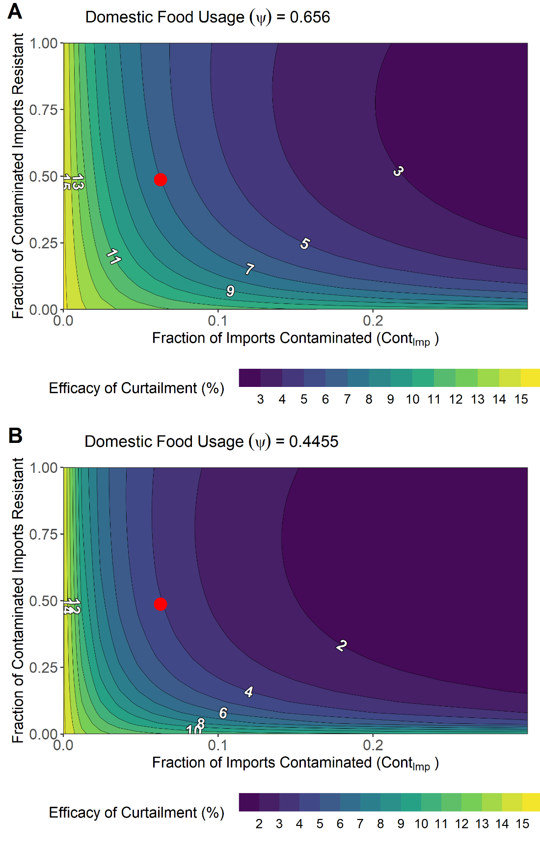

**Figure 5. Impact of altering FracImp and PropResImp import parameters on the efficacy of curtailment for two values of the proportion of UK food supply from domestic sources (ψ). A) General livestock import case study (ψ = 0.656). B) Swine food product import case study (ψ = 0.4455).** Red dot represents the baseline parameterisation for FracImp and PropResImp parameters from ECDC data (FracImp = 0.0628; PropResImp = 0.487).

Increasing proportion of imports contaminated and the proportion of ampicillin-resistant contaminated imports to the maximum explored values (FracImp = 0.3; PropResImp = 1) decreased the efficacy of curtailment relative to baseline parameterisation, with EoC being reduced from ~7% to ~2% (**Figure 5A**). Eliminating ampicillin-sensitive/resistant contamination on imports (FracImp = 0; PropResImp = 0) had the opposite effect, with an EoC of X%. A related phenomenom was also observed with decreases to the proportion of UK food supply from domestic sources (importing more) (ψ = 0.4455), with maximal reductions to FracImp and PropResImp compared to baseline (ψ = 0.656) resulting in greater reductions to EoC (X% vs X%) (**Figure 5B**).

Increases to the relative reduction in *Salmonella* spp. prevalence from domestic livestock carriage to contamination on carcasses (η = 0.20; poorer clearance) resulted in increases to the efficacy of curtailment (**SUPPLEMENTARY**). Decreases (η = 0.05; better clearance) resulted in the opposite effect when compared to equivalent reductions to FracImp and PropResImp in the baseline scenario (η = 0.1102).

An LHS-PRCC and eFAST sensitivity analysis was next conducted to assess the importance of model parameters on the efficacy of curtailment (**Figure 6**). Monotonicity plots were used to identify any potential non-monotonic behaviour (**SUPPLEMENTARY**). Among import parameters, the proportion of UK food supply from domestic sources (ψ) had a strong effect of increasing the efficacy of curtailment (coef) (**Figure 6A**). The extent of contamination on imported food products had a strong effect of reducing the efficacy of curtailment, with the proportion of ampicillin-resistant contaminated imports (coef) having a small effect of reducing the efficacy of curtailment (coef). The importance of these import parameters is corroborated by the relative height of the sensitivity indices for the first order effects in the eFAST analysis (**Figure 6B**). Second order effects comprised the majority of the variation explained by the PropResImp parameter, suggesting that interactions with other model parameters are necessary for PropResImp to affect efficacy of curtailment.

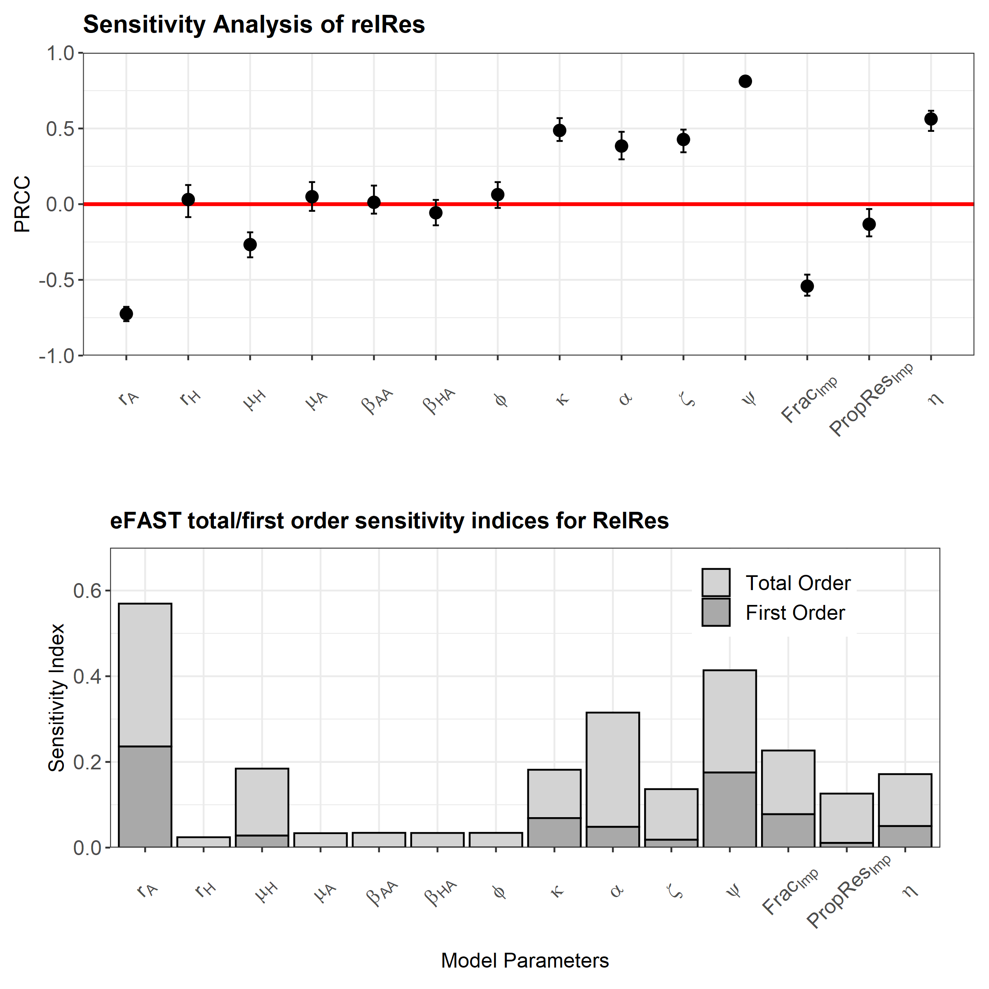

**Figure 6. Sensitivity analyses for the efficacy of curtailment (EoC) outcome measure. A) Latin hypercube sampling partial rank correlation coefficient test (LHS-PRCC). B) Extended Fourier amplitude sensitivity test (eFAST).** Note that 95% confidence intervals for each correlation coefficient was generated through generating n = 100 bootstrap replicates. The remaining proportion of the total order effects after accounting for first order effects in the eFAST can be considered the second order effects for each explored model parameter.

Among non-import related parameters, the rate of livestock recovery from *Salmonella* spp. carriage (rA) had a strong effect of reducing the efficacy of curtailment when increased (coef) (**Figure 6A**). The efficacy of antibiotic-mediated livestock recovery (κ), transmission related fitness costs associated with antibiotic-resistance (α), the per capita rate of background transmission to livestock populations (ζ) and the relative reduction in *Salmonella* spp. prevalence from domestic livestock carriage to contamination on carcasses (η) had moderate effects on increasing the efficacy of curtailment (coef).

**Section 2**

To assess the effect of heterogeneity in importation on AMR dynamics, we fitted the model with heterogenous import to the study datasets (**Figure 7A**). Import was stratified into ten distinct importing countries based on the UKs major trading partners for livestock food products: Netherlands, Irish Republic, Germany, France, Spain, Italy, Belgium, Poland, Denmark, and general non-EU import. Approximated marginal posterior probability distributions for the fitted model parameters from the ABC-SMC approach and the respective diagnostics can be found in the supplementary material (**SUPPLEMENTARY**).

**Figure 7. A) Observed and estimated relationship between livestock ampicillin usage and ampicillin-resistant salmonellosis in humans using the complex model. B) Impact of alterations in domestic livestock ampicillin usage (τ) on the daily incidence of human salmonellosis. C) Impact of alterations in domestic livestock ampicillin usage (τ) on the proportion of ampicillin-resistant human infection.** Solid red lines and ribbons represent model fit resulting from the approximated posterior distribution using ABC-SMC and the corresponding 95% HDI. Country-specific 95% confidence intervals for the observed data (dots) were calculated for each case study using a 1-sample proportion test with continuity correction. Red square denotes the target level of ampicillin-resistance (0.4167) for baseline levels of UK ampicillin usage (τ = 0.0009 g/PCU).

We note similar X-fold increases in the overall incidence of salmonellosis (X per 100.000) and X-fold decreases proportion of ampicillin-resistant human salmonellosis (.00%) compared to the previously described homogenous import model (**Figure 7B-C**). Under baseline livestock ampicillin usage (τ = 0.0009 g/PCU), the majority of overall and ampicillin-resistant human salmonellosis was attributed to domestic livestock (X%), with X% attributed to EU countries and X% attributed to non-EU sources. The extent attributable to domestic livestock to domestic livestock decreased in both outcome measures (X%; X%) when domestic ampicillin usage was curtailed (X%; X%) (**SUPPLEMENTARY**).

Alterations to the proportion of UK food from domestic livestock (ψ) were next explored in relation to the efficacy of curtailment (EoC) outcome measure (**Figure 8**). Efficacy of curtailment under baseline levels of import (ψ = 0.656) was 7% and reached a minimum/maximum value of X% and X% when under full import (ψ = 0) and no import respectively (ψ = 1). The shape of the EoC/ψ relationship under baseline parameterisation resembled an exponential-type curve, with a low efficacy of curtailment at high-moderate values of import and only increasing to the maximum EoC value at high levels of domestic usage (ψ).

**Figure 8. Relationship between the proportion of UK food products (ψ) and the efficacy of curtailment (EoC) for baseline parameterisation.** Using the values of EoC for the maximum and minimum values of ψ, we can split the figure into two sections: an area where import has a greater negative impact on lowering EoC (red area) and an area where import has a lower negative impact on lowering the EoC (green area).

We can define two areas on the EoC/ψ plot, defined by the minimum and maximum value of EoC obtained under full and no importation (**X**) **Figure 8**). The first area contains EoC/ψ relationships similar to baseline (bottom-right of plot), where EoC is low for a large range of import values, and increasing rapidly when import is at low levels. This has a EoC/ψ relationship with a shape similar to an exponential growth curve and we can denote this area as “greater impact of import”. The second area contains EoC/ψ curves where EoC is high at relatively high levels of import (top-left of plot), but which plateaus as import is increased. This results in the EoC/ψ relationship having a shape akin to logarithmic growth and we can denote this area as “lower impact of import”. We note that the latter EoC/ψ curve shape is qualitatively better area for increasing importation, as high values of EoC can still be obtained despite the saturating effect of import on local interventions.

We next explored the effect of changing import characteristics across the ten importing sources on the relationship between the proportion of UK food from domestic sources (ψ) and the effiacy of curtailment (**Figure 9**). Explored parameters included the proportion of contaminated food products that are antibiotic-resistant (PropResImp) and the proportion of contaminated food imports with *Salmonella* spp. (FracImp). Note that when PropResImp/FracImp were altered, the parameters were altered across all ten importing sources. Therefore, this represents an average change in PropResImp/FracImp across all importing sources.

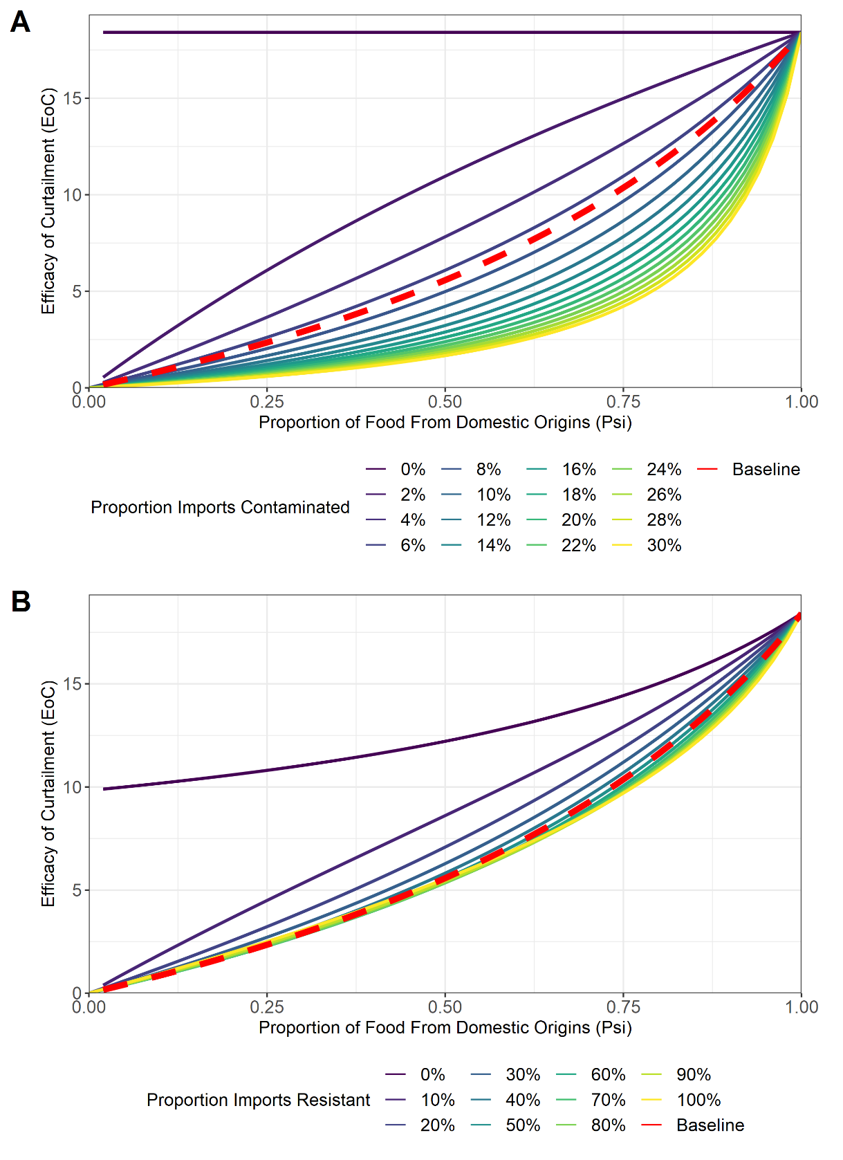

**Figure 9. Relationship between the proportion of UK food products (ψ) and the efficacy of curtailment (EoC) under different average parameterisation for FracImp and PropResImp across importing countries. A) Changes to the proportion of Salmonella spp. contaminated food imports across importing countries (FracImp). B) Changes to the proportion of ampicillin-resistant Salmonella spp. contaminated food imports across importing countries (PropResImp).** Baseline relationship between EoC/ψ is denoted by the red and dotted line. FracImp was ranged from, FracImp ϵ [0, 0.3], in accordance with the range of values observed in ECDC reports.

Decreasing the proportion of contaminated food imports (FracImp) across all importing sources to 0-4% resulted in a large shift in relationship between EoC/ψ curve to the “lower impact of import” area, where increases to import have less effect on reducing EoC (**Figure 9A**). The opposite phenomenon was observed with increases to the average FracImp above 8% with the relationship between EoC/ψ rapidly reaching a state where EoC was low across a large range of ψ values. A “saturation” type effect was also observed at higher values of FracImp, with the EoC/ψ relationship rapidly stabilising in a region where EoC remains low for a large range of ψ values. Intuitively, changes to ψ where the proportion of contaminated food imports was 0% had no impact on the EoC.

Altering the proportion of contaminated food products that are antibiotic-resistant (PropResImp) had less effect on the EoC/ψ relationship curve than alterations to FracImp (**Figure 9B**). However, decreasing PropResImp to relatively low levels (PropResImp > 20%) shifted the EoC/ψ curve into an area more favourable for import, with higher values of EoC for explored values of ψ. Interestingly, removing ampicillin-resistant contamination on imports (PropResImp = 0) resulted in changes ψ still having an impact on EoC. A “saturation” type effect was also observed with increases to PropResImp above ~40%, with minor effects on the shape of the relationship between EoC/ψ. Increases to the relative reduction in prevalence from domestic livestock carriage to contamination on carcasses (η) (lower levels of contamination) resulted in EoC/ψ relationship where EoC was low across a large range of values of ψ (**Supplementary**). Note that alterations to η resulted in a linear effect on changing the extent of *Salmonella* spp. contamination on domestic livestock carcasses (**Supplementary**).

We next explored the effect of heterogeneity in the relative contribution to import across importing countries (Share) on the relationship between the proportion of UK food from domestic sources (ψ) and the effiacy of curtailment (**Figure 10**). The Share parameter was sampled ten times, corresponding to the ten modelled importing countries/regions in the heterogeneous import model, from two different beta distributions, Beta(α = 1, β = 1) and Beta(α = 0.5, β = 2). These distributions represent two hypotheses about importation, with the relative share of import being distributed equally across importing countries or import being prioritised from a select few countries. Sampling was performed n = 1000 for each Beta distribution, and the average, minimum and maximum value of EoC for each explored value of ψ was identified.

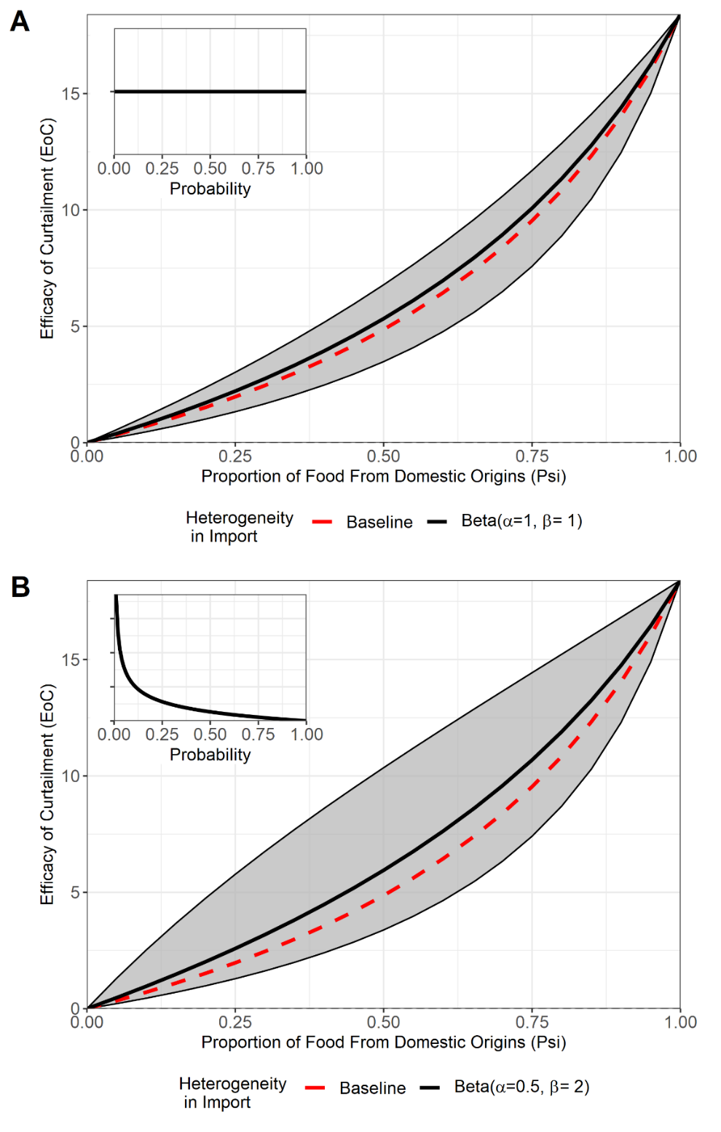

**Figure 10.** **Relationship between the proportion of UK food products (ψ) and the efficacy of curtailment (EoC) under different assumptions regarding the heterogeneity of import from importing countries. A) Share samples (n=1000) from a uniform sampling distribution, Beta(α = 1, β = 1). B) Share samples from a “skewed” sampling distribution, Beta(α = 0.5, β = 2).** Note that the average, minimum and maximum value of EoC for each value of ψ, is denoted by the middle-black line, lower bound, and upper bound of the grey shaded area respectively.Baseline relationship between EoC/ψ is denoted by the red and dotted line.

Sampling from either Beta distribution resulted in minor changes to the average EoC/ψ relationship, with minor increases in EoC across explored ψ values to baseline parameterisation. However, sampling from the Beta distribution promoting more heterogeneity, Beta(α = 0.5, β = 2), resulted in a greater heterogeneity in the minimum and maximum EoC values observed for each value of ψ compared to the distribution promoting a more uniform share of import, Beta(α = 1, β = 1) (**Figure 10**). This suggests that a more heterogeneous distribution of import across importing countries may result in greater uncertainty with the outcome of changing the extent of importation on the efficacy of local curtailment interventions. As an example, the minimum and maximum EoC values for baseline values of ψ (ψ = 0.656) were X% and X% with Beta(α = 0.5, β = 2), compared to X% and X% for Beta(α = 0.5, β = 2).

**DISCUSSION**

Two mathematical models of food importation were used to identify that increasing the amount of food import from non-domestic sources (ψ) may decrease the efficacy of domestic livestock antibiotic curtailment in the context of reducing antibiotic-resistance in livestock/humans. This was explored across a UK-specific case study for ampicillin-resistant *Salmonella* spp. in fattening pigs. Import parameters such as the proportion of UK food supply from domestic sources (ψ) and the extent of *Salmonella* spp. contamination on imports (FracImp) were important for reducing the efficacy of local livestock antibiotic curtailment (EoC). Expanding the homogenous import model to describe heterogeneity in import, identified that under a UK-specific case study, increasing the extent of non-domestic food product usage (import) resulted in sharp decreases in the efficacy of local livestock antibiotic curtailment. Increases to the average extent of *Salmonella* spp. contamination on imports had a major impact on further reducing the efficacy of curtailment when importation was increased. Increasing the heterogeneity in how import was divided across importing countries increased the level of uncertainty in the efficacy of curtailment following changes to import.

A key result of this study demonstrated that an external AMR transmission pressure due to food import may disrupt domestic AMR interventions such as livestock antibiotic curtailment. Increasing this external transmission had the effect of promoting antibiotic-sensitive/resistant foodborne disease attributable to imported sources, unaffected by domestic livestock interventions. By extension, decreasing the extent of UK food usage from domestic sources (ψ) and increasing the extent of overall or ampicillin-resistant *Salmonella* spp. contamination on imports (FracImp and PropResImp) increases imported-attributable foodborne disease, resulting in a greater disruption of the efficacy of local antibiotic curtailment. Interestingly, this also applied to more efficacious reductions in *Salmonella* spp. prevalence from livestock carriage to carcass contamination (ψ) and increases in the rate of *Salmonella* spp. clearance in fattening pigs (rA), which reduces foodborne disease attributable to domestic livestock and similarly disrupts the efficacy of local livestock curtailment.

The relationship between the proportion of UK food products from domestic sources (ψ) and the efficacy of curtailment was also a key result for this study. If a greater amount of importation is desired, then it is objectively better to shift the EoC/ψ relationship to an area where EoC remains high for a large range of import values (Figure 5; green area). Interestingly, the baseline UK case study occupies the opposing area, with increases in import (ψ < 0.656), quickly resulting in large decreases to EoC. This suggests that increasing the extent of UK food products from imported sources may result in a disruption in the efficacy of local livestock curtailment strategies. This has clear ramifications for trade and public health policy, with the UK’s withdrawal from the EU potentially changing established trade networks, a lack of clarity/delays in the replacement of European Common Agricultural Policy (CAP) subsidies for UK farmers and a shortage of labour having the potential for unforeseen impacts on domestic production and future reliance on non-domestic food products (47-50). Focus must therefore be placed on ensuring good domestic, import and border biosecurity/surveillance for food products if changes in import are projected in order to protect the efficacy of livestock antibiotic curtailment (51-53).

The balance between the average level of contamination on imported food products and the extent of contamination on domestic food products/carcasses drives the shape of the relationship between EoC/ψ. High levels of domestic food contamination relative to contamination on imports results in a more positive EoC/ψ relationship (Figure X; green area). Conversely, as with the UK case study, EoC/ψ relationship sits in a less advantageous area for increasing import (**X**), due to the average level of non-domestic contamination exceeding that of domestic livestock food product contamination (**X**). As an illustrative example, changes to η = … % result in import/domestic contamination being roughly equal, with a near linear relationship between EoC/ψ (**Supplementary**). This also suggests that alternative case studies with higher levels of domestic contamination/resistance would result in a higher EoC across explored import values (Figure X; green area), due to the higher level of foodborne disease attributable to domestic sources.

Interestingly, there is also the existence of a saturation effect, with increases in the average level of overall/ampicillin contamination on imports (**X**) above baseline values (**X**) quickly stabilising at a relationship where increase in import results in the largest decreases to the efficacy of curtailment (**Figure 9**). This suggests that relatively small increases in import contamination can greatly diminish the efficacy of local livestock antibiotic curtailment on human health if the extent of food importation is then altered. This highlights the critical need for substantial import surveillance and control of food product contamination (52, 53).

Heterogeneity in the relative share of importing countries to overall import (Share) had little effect on altering the average effect of import on the efficacy of curtailment. This can be attributable to the relatively homogenous nature of contamination and resistance observed in the data used for import parameterisation (**Supplementary Table**). In contrast, increasing heterogeneity in import reliance (Share) and also in the level of contamination/resistance across importing countries (FracImp; PropResImp), would have the effect of increasing the likelihood of relying on imports from a country/region with a high level of *Salmonella* spp. and increasing the average extent of contamination/resistance, negatively affecting the average the EoC/ψ relationship (**Supplementary**).

The strong influence of the average level of contamination/resistance on imports can be attributed to the star topology of the food product import network, with a single internal node (domestic) with degree () and nodes with degree 1 (importing) (54). This network results in no interactions between importing countries, and the domestic country acting as a central hub for trade. Therefore, the relationship between import parameters (FracImpn*PropResImpn*Sharen*ψ) across each importing country is the sole factor in determining the extent of import-attributable foodborne disease. This contrasts with other AMR studies which model higher levels of interaction between subpopulations and demonstrating a greater influence of network structure on the qualitative dynamics of AMR transmission/interventions (22, 23). This connected structure may be more suited to future models exploring the import/trade of breeding animals, which have greater levels of motility across international borders and agricultural settings (55).

This has clear trade/public health consequences, with many countries often preferring greater heterogeneity in import, expressed as a higher reliance on a small number of “reliable” trading partners (56). While this is beneficial if these select trading partners have low levels of contamination/resistance, it also decreases the resilience of the trade network to external shocks such as price increases, export bans or interruptions in trade, as observed with COVID-19 or climate change (29, 57). The alternative is spreading imports across many trading partners, which may increase resilience of trading networks (56). However, this approach would require a harmonised regional approach across all trading partners to bring down the average level of contamination on imports/resistance to avoid detrimental impacts on the efficacy of curtailment. Clear examples of this can be seen with EU regulation to ensure good biosecurity and food standards across member states (58). Future models would benefit from including an economic component to assess the economic viability and effect on AMR from changing import trade structure (59).

The importance of the average extent of *Salmonella* spp. contamination/resistance and the existence of a saturation effect suggests that the extent of average overall/ampicillin-resistant contamination should be decreased as low as possible if changes to the extent of importation are desired. Or at the very least, reducing contamination to an equal level seen on domestic food products to preserve the efficacy of curtailment of local livestock antibiotic stewardship on human health (Figure 9A). This is particularly relevant in countries such as the UK case study, where the level of *Salmonella* spp. carcass contamination is already low relative to imports (**SUPPLEMENTARY**). The need to understand the balance of contamination/resistance between imports and domestic food products also highlights the critical need for foodborne pathogen/AMR surveillance at the origin of import, the point of entry and also within domestic livestock (51).

Examples of surveillance and interventions to reduce import contamination at the point of origin include EU requirements for so-called “third-country” importing organisations not within the EU framework to meet EU food safety requirements and submit to inspection by Food and Vetrinary Office (FVO) officers (60). Stringent inspection at border control posts at the point of import has also been widely recognised as a standardised method to reduce consumer exposure to contamination on imports (51, 60). Harmonised systems such as the Rapid Alert System for Food and Feed (RASFF) has also been shown as effective as spreading the burden of BCP checks across multiple countries, with identification of contaminants and sources of single/multi-country foodborne pathogen outbreaks in one country, rapidly sent as an alert to all RASFF-participants (61, 62). Policy to reduce import contamination can also be introduced at a macro-scale, controlling which countries to form import based trade connections with based on the extent of contamination on food products. The clearest example of this includes EU differentiation of food product “trade” between member states and “imports/introductions” from non-member state “third countries” with a higher amount of regulation and inspection placed on trade from the latter (60). Adherence to these measures can ensure that contamination can be kept at low levels to avoid potential decreases to the efficacy of curtailment following changes in food importation.

However, there are limitations with current surveillance. For example, surveillance on AMR in livestock and food products is limited outside of the EU, with a lack of high quality, harmonised farm-to-fork AMR surveillance systems (63, 64). This is relevant given the importance of antibiotic-resistant *Salmonella* spp. contamination on the efficacy of curtailment (**Figure 9A**). Additionally, BCP checks are often limited to occasional physical checks, which may limit the surveillance of AMR/contamination, with a compromise between ensuring rapid transit into the importing country and the use labour intensive/costly microbiological testing (51). While it is unfair to expect rapid WGS to provide “on-the-spot” identification of microbiological contamination on imports, expansion of sampling of imported food products at BCPs for retroactive sequencing and analysis could provide a rich vein for future AMR surveillance and analysis (65). Use of WGS data for COVID-19 phylodynamic modelling, identification of AMR transmission events and for source attribution in previous analyses has identified the power of this high-resolution and standardised WGS information to assess pathogen dynamics and potentially inform future AMR modelling studies (10, 19, 66, 67).

Source attribution studies have attributed pigs, layers and travel as the primary sources of human salmonellosis, with the influence of imported food products limited to 6.4-9.9% (20). This suggests an overestimation of the influence of imported livestock food products contributing to human salmonellosis in this study (**Figure 7B**). However, this is caveated by a lack of information on UK-specific salmonellosis source attribution and the lack of multiple livestock hosts/travel-related infection in this study model (20, 68). It is also important to recognise the recent advances in AMR source attribution using metagenomic approaches, which may provide an avenue for model parameterisation for the AMR attributable fractions (19).

It is important to note that both models assumed a relationship between domestic livestock antibiotic usage and human antimicrobial resistance. While there is evidence suggesting changes in human AMR following livestock AMR interventions, it is important to note that there is no consensus regarding widespread transmission of AMR between livestock and humans, with one-health AMR interventions introduced under a precautionary principle approach (5, 69). However, we note that the use of *Salmonella* spp. as a case study represents one of the clearest possible pathways for AMR to transmit from livestock to humans. This can be attributed to the lack of human carriage of certain host-restricted serovars of *Salmonella* spp., the presence of established livestock reservoirs and strong evidence of AMR and pathogen contamination along the farm-to-fork pathway (12).

This study provides a quantitative framework to explore intuition in AMR research, that the influence of non-domestic food usage may potentially alter local AMR dynamics. We highlight the importance of livestock food product import on potentially reducing the efficacy of local livestock antibiotic curtailment with regard to reducing AMR in human populations. The efficacy of local antibiotic curtailment was explored in the context of altering the extent of importation, using a UK-specific case study as the domestic country of interest. The importance of importation on AMR dynamics suggest that future trade policy changes must also consider the potential effects on AMR, particularly within the context of livestock food products, foodborne disease, and the viability of “one health” strategies.

**REFERENCES**

1. McEwen SA, Collignon PJ. Antimicrobial resistance: a one health perspective. Microbiology spectrum. 2018;6(2):6.2. 10.

2. Woolhouse M, Ward M, Van Bunnik B, Farrar J. Antimicrobial resistance in humans, livestock and the wider environment. Philosophical Transactions of the Royal Society B: Biological Sciences. 2015;370(1670):20140083.

3. Muloi D, Ward MJ, Pedersen AB, Fevre EM, Woolhouse ME, van Bunnik BA. Are food animals responsible for transfer of antimicrobial-resistant Escherichia coli or their resistance determinants to human populations? A systematic review. Foodborne pathogens and disease. 2018;15(8):467-74.

4. Giufre M, Graziani C, Accogli M, Luzzi I, Busani L, Cerquetti M. Escherichia coli of human and avian origin: detection of clonal groups associated with fluoroquinolone and multidrug resistance in Italy. Journal of Antimicrobial Chemotherapy. 2012;67(4):860-7.

5. Tang KL, Caffrey NP, Nóbrega DB, Cork SC, Ronksley PE, Barkema HW, et al. Restricting the use of antibiotics in food-producing animals and its associations with antibiotic resistance in food-producing animals and human beings: a systematic review and meta-analysis. The Lancet Planetary Health. 2017;1(8):e316-e27.

6. Tacket CO, Dominguez LB, Fisher HJ, Cohen ML. An outbreak of multiple-drug-resistant Salmonella enteritis from raw milk. Jama. 1985;253(14):2058-60.

7. Lazarus B, Paterson DL, Mollinger JL, Rogers BA. Do human extraintestinal Escherichia coli infections resistant to expanded-spectrum cephalosporins originate from food-producing animals? A systematic review. Clinical Infectious Diseases. 2015;60(3):439-52.

8. Gouliouris T, Raven KE, Ludden C, Blane B, Corander J, Horner CS, et al. Genomic surveillance of Enterococcus faecium reveals limited sharing of strains and resistance genes between livestock and humans in the United Kingdom. MBio. 2018;9(6):e01780-18.

9. Ludden C, Raven KE, Jamrozy D, Gouliouris T, Blane B, Coll F, et al. One health genomic surveillance of Escherichia coli demonstrates distinct lineages and mobile genetic elements in isolates from humans versus livestock. MBio. 2019;10(1):e02693-18.

10. Wee BA, Muloi DM, van Bunnik BA. Quantifying the transmission of antimicrobial resistance at the human and livestock interface with genomics. Clinical Microbiology and Infection. 2020;26(12):1612-6.

11. Pokharel S, Shrestha P, Adhikari B. Antimicrobial use in food animals and human health: time to implement ‘One Health’approach. Antimicrobial Resistance & Infection Control. 2020;9(1):1-5.

12. Stevens MP, Humphrey TJ, Maskell DJ. Molecular insights into farm animal and zoonotic Salmonella infections. Philosophical Transactions of the Royal Society B: Biological Sciences. 2009;364(1530):2709-23.

13. Marshall BM, Levy SB. Food animals and antimicrobials: impacts on human health. Clinical microbiology reviews. 2011;24(4):718-33.

14. Ma F, Xu S, Tang Z, Li Z, Zhang L. Use of antimicrobials in food animals and impact of transmission of antimicrobial resistance on humans. Biosafety and Health. 2021;3(01):32-8.

15. George A. Antimicrobial resistance (AMR) in the food chain: trade, one health and codex. Tropical medicine and infectious disease. 2019;4(1):54.

16. Jung D, Morrison BJ, Rubin JE. A review of antimicrobial resistance in imported foods. Canadian Journal of Microbiology. 2022;68(1):1-15.

17. Jans C, Sarno E, Collineau L, Meile L, Stärk KD, Stephan R. Consumer exposure to antimicrobial resistant bacteria from food at Swiss retail level. Frontiers in microbiology. 2018;9:362.

18. Mateus A, Takahashi E, Elkholly D, Crotta M, Ekiri A, Guinat C, et al. A systematic review of AMR bacteria in pork, poultry, dairy products, seafood and fresh produce at UK retail level. Food Standards Agency. 2016.

19. Duarte ASR, Röder T, Van Gompel L, Petersen TN, Hansen RB, Hansen IM, et al. Metagenomics-Based Approach to Source-Attribution of Antimicrobial Resistance Determinants–Identification of Reservoir Resistome Signatures. Frontiers in microbiology. 2021:3447.

20. Pires SM, Vieira AR, Hald T, Cole D. Source attribution of human salmonellosis: an overview of methods and estimates. Foodborne pathogens and disease. 2014;11(9):667-76.

21. Keeling MJ, Rohani P. Modeling infectious diseases in humans and animals: Princeton university press; 2011.

22. Krieger MS, Denison CE, Anderson TL, Nowak MA, Hill AL. Population structure across scales facilitates coexistence and spatial heterogeneity of antibiotic-resistant infections. PLoS computational biology. 2020;16(7):e1008010.

23. Olesen SW, Lipsitch M, Grad YH. The role of “spillover” in antibiotic resistance. Proceedings of the National Academy of Sciences. 2020;117(46):29063-8.

24. Blanquart F, Lehtinen S, Lipsitch M, Fraser C. The evolution of antibiotic resistance in a structured host population. Journal of The Royal Society Interface. 2018;15(143):20180040.

25. Gehlhar M, Coyle W. Global food consumption and impacts on trade patterns. Changing structure of global food consumption and trade. 2001:4-13.

26. Zhao H, Chang J, Havlík P, van Dijk M, Valin H, Janssens C, et al. China’s future food demand and its implications for trade and environment. Nature Sustainability. 2021;4(12):1042-51.

27. Kinnunen P, Guillaume JH, Taka M, D’odorico P, Siebert S, Puma MJ, et al. Local food crop production can fulfil demand for less than one-third of the population. Nature Food. 2020;1(4):229-37.

28. Porkka M, Guillaume JH, Siebert S, Schaphoff S, Kummu M. The use of food imports to overcome local limits to growth. Earth's Future. 2017;5(4):393-407.

29. Department for Environment FRA. United Kingdom Food Security Report 2021. United Kingdom: Department for Environment, Food & Rural Affairs; 2021 16/12/21.

30. Maron DF, Smith TJ, Nachman KE. Restrictions on antimicrobial use in food animal production: an international regulatory and economic survey. Globalization and health. 2013;9(1):1-11.

31. Martelli F, Oastler C, Barker A, Jackson G, Smith R, Davies R. Abattoir-based study of Salmonella prevalence in pigs at slaughter in Great Britain. Epidemiology & Infection. 2021;149.

32. Alvseike O, Prieto M, Bjørnstad PH, Mason A. Intact gastro-intestinal tract removal from pig carcasses in a novel Meat Factory Cell approach. Acta Veterinaria Scandinavica. 2020;62(1):1-5.

33. Authority EFS, Prevention ECfD, Control. The European Union summary report on antimicrobial resistance in zoonotic and indicator bacteria from humans, animals and food in 2015. EFSA Journal. 2017;15(2):e04694.

34. Authority EFS, Prevention ECfD, Control. The European Union summary report on antimicrobial resistance in zoonotic and indicator bacteria from humans, animals and food in 2016. EFSA Journal. 2018;16(2):e05182.

35. Authority EFS, Prevention ECfD, Control. The European Union summary report on antimicrobial resistance in zoonotic and indicator bacteria from humans, animals and food in 2017. EFSA Journal. 2019;17(2):e05598.

36. Authority EFS, Prevention ECfD, Control. The European Union Summary Report on Antimicrobial Resistance in zoonotic and indicator bacteria from humans, animals and food in 2017/2018. EFSA Journal. 2020;18(3):e06007.

37. European Medicines Agency ESoVAC. Sales of veterinary antimicrobial agents in 31 European countries in 2015. European Medicines Agency; 2017.

38. European Medicines Agency ESoVAC. Sales of veterinary antimicrobial agents in 31 European countries in 2016. European Medicines Agency; 2018.

39. European Medicines Agency ESoVAC. Sales of veterinary antimicrobial agents in 31 European countries in 2017. European Medicines Agency; 2019.

40. European Medicines Agency ESoVAC. Sales of veterinary antimicrobial agents in 31 European countries in 2018. European Medicines Agency; 2020.

41. Department for Environment FaRA. Agriculture in the United Kingdom 2019. Department for Environment, Food and Rural Affairs; 2020 25/06/20.

42. Authority EFS. The European Union summary report on trends and sources of zoonoses, zoonotic agents and food‐borne outbreaks in 2016. EFSA journal. 2017;15(12).

43. Authority EFS, Prevention ECfD, Control. The European Union summary report on trends and sources of zoonoses, zoonotic agents and food‐borne outbreaks in 2015. EFSA Journal. 2016;14(12):e04634.

44. Authority EFS, Prevention ECfD, Control. The European Union summary report on trends and sources of zoonoses, zoonotic agents and food‐borne outbreaks in 2017. EFSa Journal. 2018;16(12):e05500.

45. Authority EFS, Prevention ECfD, Control. The European Union one health 2018 zoonoses report. EFSA Journal. 2019;17(12):e05926.

46. Cassini A, Colzani E, Pini A, Mangen M-JJ, Plass D, McDonald SA, et al. Impact of infectious diseases on population health using incidence-based disability-adjusted life years (DALYs): results from the Burden of Communicable Diseases in Europe study, European Union and European Economic Area countries, 2009 to 2013. Eurosurveillance. 2018;23(16):17-00454.

47. Department for Environment FRA. The Environmental Land Management scheme. United Kingdom: National Audit Office (NAO) 2021 15/09/21.

48. Choi HS, Jansson T, Matthews A, Mittenzwei K. European agriculture after Brexit: does anyone benefit from the divorce? Journal of Agricultural Economics. 2021;72(1):3-24.

49. Helm D. Agriculture after brexit. Oxford Review of Economic Policy. 2017;33(suppl_1):S124-S33.

50. Accounts HoCCoP. Environmental Land Management Scheme - Thirty-First Report of Session 2021–22. United Kingdom: The Committee of Public Accounts; 2021 09/01/2022.

51. Administration UFD. FDA Strategy for the Safety of Imported Food United States: US Food & Drug Administration; 2019 01/02/19.

52. Tauxe R. Addressing foodborne threats to health: Policies, practices and global coordination Workshop summary. Washington, DC: The National Academies Press; 2006.

53. Council NR. Scientific criteria to ensure safe food: National Academies Press; 2003.

54. Weisstein EW. Star Graph. <https://mathworld> wolfram com/. 2006.

55. Hardstaff JL, Häsler B, Rushton JR. Livestock trade networks for guiding animal health surveillance. BMC veterinary research. 2015;11(1):1-13.

56. Kummu M, Kinnunen P, Lehikoinen E, Porkka M, Queiroz C, Röös E, et al. Interplay of trade and food system resilience: Gains on supply diversity over time at the cost of trade independency. Global Food Security. 2020;24:100360.

57. van Berkum S. How trade can drive inclusive and sustainable food system outcomes in food deficit low-income countries. Food Security. 2021;13(6):1541-54.

58. Commission E. Animal products: movements within the Union and entry into the EU [Webpage]. Directorate-General for Health and Food Safety; 2022 [Available from: <https://ec.europa.eu/food/animals/animal-products-movements_en>.

59. Perrings C, Levin S, Daszak P. The economics of infectious disease, trade and pandemic risk. Springer; 2018. p. 241-3.

60. Commission E. General guidance on EU import and transit rules for live animals and animal products from third countries. General Guidance. European Commission, Commission E; 2010 17/08/2010.

61. Kowalska A, Manning L. Using the rapid alert system for food and feed: Potential benefits and problems on data interpretation. Critical Reviews in Food Science and Nutrition. 2021;61(6):906-19.

62. Commission E. RASFF - The Rapid Alert System for Food and Feed - Annual Report 2020. Luxembourg: European Commission, Commission E; 2021 2021.

63. Van Boeckel TP, Pires J, Silvester R, Zhao C, Song J, Criscuolo NG, et al. Global trends in antimicrobial resistance in animals in low-and middle-income countries. Science. 2019;365(6459):eaaw1944.

64. Criscuolo NG, Pires J, Zhao C, Van Boeckel TP. resistancebank. org, an open-access repository for surveys of antimicrobial resistance in animals. Scientific Data. 2021;8(1):1-10.

65. Grant K, Jenkins C, Arnold C, Green J, Zambon M. Implementing pathogen genomics: a case study. United Kingdom: Public Health England, England PH; 2018 02/08/18.

66. Kraemer MU, Hill V, Ruis C, Dellicour S, Bajaj S, McCrone JT, et al. Spatiotemporal invasion dynamics of SARS-CoV-2 lineage B. 1.1. 7 emergence. Science. 2021;373(6557):889-95.

67. Du Plessis L, McCrone JT, Zarebski AE, Hill V, Ruis C, Gutierrez B, et al. Establishment and lineage dynamics of the SARS-CoV-2 epidemic in the UK. Science. 2021;371(6530):708-12.

68. Domingues A, Pires SM, Halasa T, Hald T. Source attribution of human salmonellosis using a meta-analysis of case-control studies of sporadic infections. Epidemiology & Infection. 2012;140(6):959-69.

69. Phillips I, Casewell M, Cox T, De Groot B, Friis C, Jones R, et al. Does the use of antibiotics in food animals pose a risk to human health? A critical review of published data. Journal of antimicrobial chemotherapy. 2004;53(1):28-52.